**Tolerating toxins: grasshoppers that feast on pyrrolizidine alkaloidsa**

Catherine E. Housecroft*

\**Correspondence*: Prof. C. Housecroft, Department of Chemistry, University of Basel, BPR 1096, Mattenstrasse 24a, CH-4058 Basel, Email: catherine.housecroft@unibas.ch

*Abstract*: The elegant grasshopper (*Zonocerus elegans*) and the variegated grasshopper (*Z. variegatus)* are among insects that deliberately consume and store pyrrolizidine alkaloids which are subsequently used in defense mechanisms.

**Keywords**: Alkaloids · Chemical education · Grasshoppers

Elegant grasshoppers (*Zonocerus elegans*) are widespread in South Africa and easily recognized by their bright colours and bold markings (Fig. 1). Juvenile elegant grasshoppers are also strikingly marked (Fig. 2). The related variegated grasshopper (*Z. variegatus*) occurs in western and equatorial Africa and is also brightly coloured. Such coloration is often symptomatic of a chemical defense against potential predators. The association of colour with a defense strategy is known as *aposematism*. *Z. elegans* and *Z. variegatus* are examples of insects that have the ability to consume plants containing toxins and store the toxic compounds. For the host plants, this is somewhat ironic because they produce toxic alkaloids (which taste very bitter) to discourage herbivores from eating them.

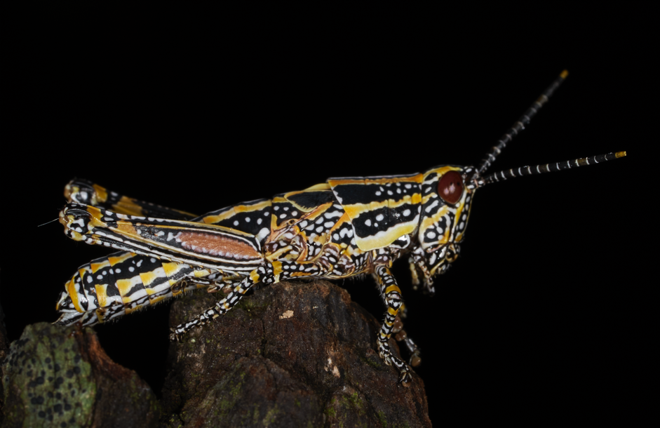

Fig. 1. The elegant grasshopper (*Zonocerus elegans*). ©Edwin C. Constable 2018.

The toxins ingested by Z. elegans belong to the family of pyrrolizidine alkaloids. Alkaloids are a large group of naturally occurring organic nitrogen-containing bases, typically heterocyclic compounds, which are chiral and occur naturally as a single enantiomer. Well-known examples are nicotine, morphine, caffeine, quinine, cocaine and strychnine [1].

In pyrrolizidine alkaloids [2,3] (Fig. 3), the nitrogen-heterocycle is bicyclic as exemplified by the alkaloids heliotrine and senecionine (Fig. 3), both of which are ingested by *Z. elegans*. It is not by accident that *Z. elegans* encounters plants containing these alkaloids. These

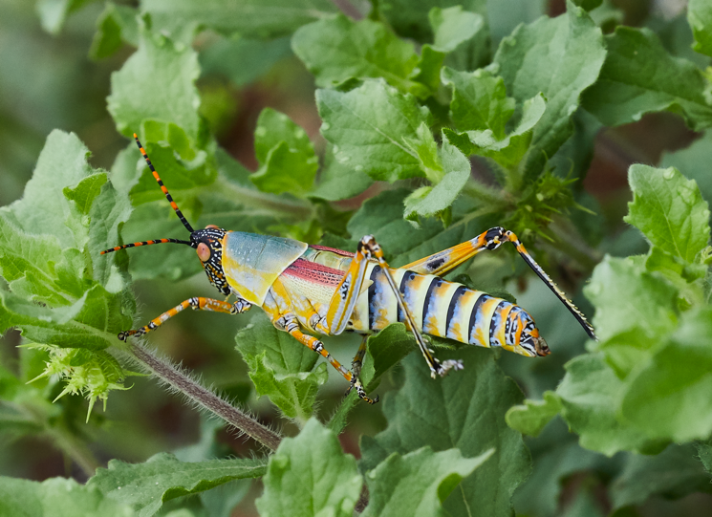

Fig. 2. Juvenile elegant grasshopper (*Z. elegans*). ©Edwin C. Constable 2018.

insects can detect toxins up to several metres away. One study descibes *Z. elegans* as 'eagerly' trying to reach host plants, even biting through gauzes covering the food [4]. In this investigation, *Z. elegans* was also attracted to neat heliotrine, avoiding control dishes with no alkaloids. Significantly, grasshoppers of other families showed no interest in the alkaloids in the experiment. It is also clear that *Z. elegans* searches out pyrrolizidine alkaloids independently of looking for food for survival. This habit is referred to as *pharmacophagy*, defined by Boppré as searching directly for secondary plant substances, ingesting them, and using them for specific purposes other than primary metabolism [5].

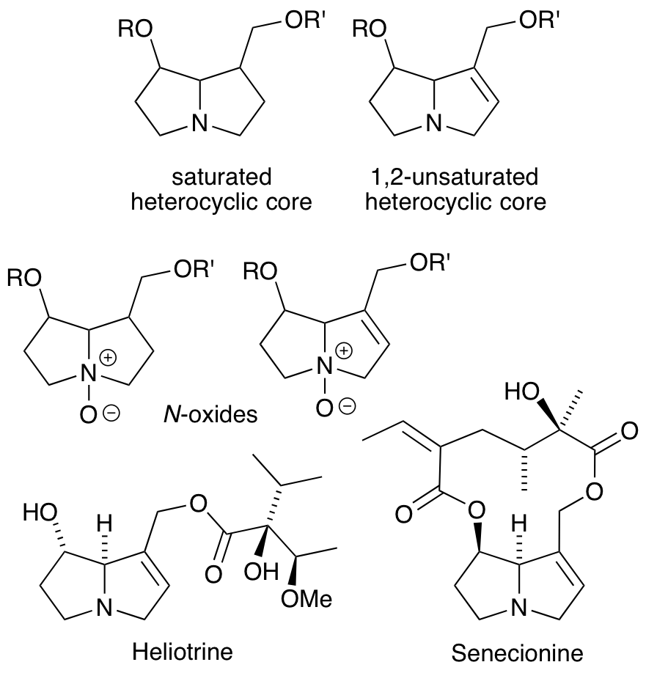

Fig. 3. General core structures of pyrrolizidine alkaloids and their *N*-oxides, and examples of pyrrolizidine alkaloids to which *Z. elegans* is attracted.

Once ingested, how does the grasshopper deal with the toxins? A vital clue comes from a study [6] in which *Z. variegatus* was fed 14C-labelled sencionine and its *N*-oxide (Fig. 3). After a period of normal food intake, the grasshoppers were killed, crushed in liquid N2 and extracted with methanol/HCl. Despite being fed on both the alkaloid and its *N*-oxide, only 14C-labelled sencionine *N*-oxide was present in the final extract. Crucially, the amount of sencionine *N*-oxide in the extract was essentially the same for grasshoppers that had consumed only sencionine or only sencionine *N*-oxide*.* In a follow-up experiment, *Z. variegatus* was fed 18O-labelled sencionine *N*-oxide, and it was found that (after following the same extraction procedure as above), there was complete loss of the 18O label from recovered sencionine *N*-oxide. These results demonstrate that the pyrrolizidine alkaloid *N*-oxide taken in by *Z. variegatus* is reduced in the insect's gut and that the alkaloid itself passes into the haemolymph (the circulating fluid in insects) where it is then converted to the non-toxic alkaloid *N*-oxide. This oxidation is catalysed by a highly substrate-specific enzyme (sencionine *N*-oxygenase) and it is this that ensures that the alkaloid is stored in *Zonocerus* grasshoppers in a non-toxic form. Finally we come to the defense mechanism. Vertebrate predators eating *Zonocerus* consume pyrrolizidine alkaloid *N*-oxides which are readily reduced in the animal's gut, thus regenerating the toxin.

**References**

[1]. For basic information on alkaloids, see: C.E. Housecroft, E.C. Constable, *Chemistry*, 4th Edn, Prentice Hall, Harlow, **2010**, p. 1244.

[2]. J.A. Saunders, N.R. O'Neill, J.T. Romeo in *Alkaloids: Chemical and biological perspectives,* ed. S.W. Pelletier, Springer-Verlag, New York, vol. 8. Ch. 2, **1992**.

[4]. M. Boppré, U. Seibt, W. Wickler, *Entomol. Exp. Appl.* **1984**, *35*, 115–117.

[3]. A. El-Shazly, M. Wink, *Diversity* **2014**, *6*, 188–282.

[5]. M. Boppré, *J. Chem. Ecol.* **1984**, *10*, 1151–1154.

[6]. R. Lindigkeit, A. Biller, M. Buch, H.-M. Schiebel, M. Boppré, T. Hartmann, *Eur. J. Biochem.* **1997**, *245*, 626–636.

aThis column is the first in a series and is designed to attract teachers to topics that link chemistry to Nature and stimulate students by seeing real-life applications of the subject.